Development Of Interactive Multimedia-Based Learning Media

¹Hamisah, ²Ferry Marlianto,³Nurbani,⁴Baharuddin JH
^{1,2,3,4}Universitas PGRI Pontianak,Jalan Ampera Raya Kotabaru Pontianak,Kalimantan Barat,Indonesia

ABSTRACT
The integration of digital technologies in education has heightened the need for pedagogical innovations that enhance conceptual understanding and student engagement, particularly in subjects involving abstract technical content such as Computer Systems. This study aimed to develop and evaluate an interactive multimedia learning application using Smart Apps Creator (SAC 3) for Grade X Informatics students at SMA Negeri 01 Boyan Tanjung. Employing a Research and Development (R&D) methodology grounded in the ADDIE model, the study systematically carried out needs analysis, instructional design, multimedia development, classroom implementation, and formative evaluation. Data were collected through expert validation sheets, student response questionnaires, observations, and documentation, and analyzed using descriptive statistics.
Results from expert validators indicated high levels of feasibility, with media experts awarding scores of 88.09% and 91.66%, and material experts assigning 93.18% and 84.09%, placing the product in the “Very Valid” category. Classroom implementation involving both small- and large-scale trials demonstrated strong student engagement and positive perceptions, with overall student response reaching 85.14%, categorized as “Very Good.” The interactive multimedia effectively supported learners in visualizing system components, reduced cognitive load, and increased motivation compared to traditional teaching resources. The findings affirm that SAC-based multimedia constitutes a practical and pedagogically robust solution for enhancing the teaching of Computer Systems, particularly in schools with limited infrastructure. Future research should incorporate experimental measurements of learning gains and broaden implementation across diverse educational contexts.
Keywords: interactive multimedia, Smart Apps Creator, Informatics education, computer systems, ADDIE model, instructional design.

1. INTRODUCTION
The accelerating digitalization of education has fundamentally reshaped how learning occurs, demanding that schools adopt pedagogical strategies that cultivate students’ technological fluency, adaptability, and digital problem-solving skills. Around the world, scholars argue that meaningful technology integration is no longer optional but essential for preparing learners to participate in increasingly computational societies (Kong et al., 2022; Voogt & Roblin, 2019). Indonesia has responded to these developments through curriculum reform that formally positions Informatics as a compulsory subject at the secondary level, aiming to strengthen students’ computational thinking, information literacy, and understanding of digital systems. The Informatics curriculum encompasses eight core elements—including Computer Systems—each of which plays a foundational role in enabling learners to interpret and operate within digital environments (Wahyono et al., 2021) .
Yet despite national policy support, classroom realities in many Indonesian schools remain constrained by limited instructional media, teacher-centered delivery, and students’ difficulties in conceptualizing abstract technological content. Preliminary observations conducted at SMA Negeri 01 Boyan Tanjung indicate that students frequently struggle to comprehend the underlying architecture of computer systems, including the functional relationships among hardware, software, and users. Teachers often rely solely on worksheets and printed textbooks, which provide insufficient representational support for topics that require visualization, such as CPU processes, memory structures, and input–output operations. The absence of interactive learning tools leads to reduced engagement, fragmented comprehension, and the need for repeated explanation, ultimately slowing the instructional process (Pristiwanti et al., 2022; Yaumi, 2018; see also classroom observations in the school context ).
At the same time, students at the school have widespread access to Android smartphones, yet these devices remain underutilized as learning tools. This condition reflects what scholars describe as a second-level digital divide, in which access exists but meaningful educational use does not (van Deursen & Helsper, 2018). The challenge is therefore not technological scarcity, but the absence of pedagogically grounded digital learning media aligned with the curriculum. To bridge this gap, interactive multimedia has been widely recognized as a powerful means of enhancing learning, especially in subjects requiring abstract reasoning. Research consistently shows that multimedia integrating text, visuals, audio, and animations supports dual-channel cognitive processing, improves motivation, and strengthens conceptual understanding (Mayer, 2021; Chen et al., 2018). When learners can visualize system components, manipulate interfaces, and receive immediate feedback, cognitive load is reduced, and deeper, more durable learning occurs.
Smart Apps Creator (SAC 3), a code-free multimedia authoring tool, offers an accessible yet robust platform for creating such instructional media. SAC 3 enables educators to design interactive digital modules that can run offline on smartphones, laptops, and tablets—an essential advantage for schools with infrastructure limitations. Prior studies show that SAC-based applications are effective, valid, and practical across diverse subjects, yielding high learner engagement and strong pedagogical outcomes (Azizah, 2020; Karlinda, 2021; Saputra et al., 2023; Mustafa et al., 2023). However, comparatively few studies have examined its use in secondary-level Informatics education, particularly for teaching foundational Computer Systems concepts, despite the clear pedagogical need for interactive visual representation and flexible student-paced learning.
Responding to this gap, the present study develops and evaluates an interactive multimedia learning application using Smart Apps Creator (SAC 3) specifically designed for the Computer Systems unit in Grade X Informatics. This study follows the ADDIE instructional design model—Analysis, Design, Development, Implementation, and Evaluation—to ensure systematic development and iterative refinement (Aldoobie, 2015; Sugiyono, 2019). The model provides a rigorous framework for identifying learner needs, designing media aligned with pedagogical principles, producing prototypes, validating content with experts, and assessing user experience and feasibility through classroom trials.
Expert validation results, as well as small- and large-scale student trials at SMA Negeri 01 Boyan Tanjung, offer insights into the feasibility, practicality, and pedagogical quality of the developed multimedia. Beyond producing a functional learning product, this study contributes to the broader discourse on digital pedagogy, illustrating how interactive multimedia can operationalize constructivist, student-centered learning in contexts where traditional instructional resources are limited. Moreover, by utilizing a platform accessible to teachers without programming expertise, the study demonstrates a scalable pathway for empowering educators to create their own digital learning innovations.
In sum, this research addresses a critical intersection of curriculum reform, classroom challenges, and technological opportunity. It investigates how interactive multimedia—designed through a systematic instructional model and grounded in local learning needs—can enhance students’ understanding of computer system concepts in Indonesian secondary education. The following sections present the methodological processes undertaken and the empirical results generated through the development and testing of the SAC-based multimedia
2. METHODS
This study employed a Research and Development (R&D) design aimed at producing and validating an interactive multimedia learning application for the Computer Systems unit in Grade X Informatics. R&D is widely recognized for its emphasis on designing educational products that are systematically tested, refined, and evaluated for instructional effectiveness (Sugiyono, 2019). The model used to guide the development process was ADDIE—an instructional design framework consisting of Analysis, Design, Development, Implementation, and Evaluation—which has been extensively applied in technology-enhanced learning research due to its structured yet adaptable nature (Aldoobie, 2015). Through this framework, the research ensured that the final multimedia application was grounded in learner needs, curriculum requirements, and expert validation.
The research took place at SMA Negeri 01 Boyan Tanjung, a secondary school located in Kapuas Hulu, Indonesia, where preliminary observations revealed significant challenges in teaching computer system concepts using only textbooks and worksheets. Students often found the material abstract and difficult to visualize, while teachers faced limitations in diversifying media due to the absence of interactive digital tools. Although most students possessed Android smartphones capable of supporting learning applications, these devices had not been utilized as instructional media. This context informed the analytical foundation of the ADDIE model, which served as the onset of the research process.
During the Analysis phase, the researcher investigated three essential dimensions. The first was the profile and characteristics of learners, which involved understanding the technological access, learning preferences, and prior knowledge of Grade X students. Interviews with the Informatics teacher confirmed that students struggled with conceptual topics such as CPU structure, memory processes, and hardware–software interaction, primarily due to the lack of visual and interactive resources. Classroom observations further established that the conventional lecture-based method reduced student attention and engagement, prompting the need for a more responsive, student-centered medium . The second analytical dimension focused on content needs, identifying that the curriculum required mastery of system components, device functions, and their interrelationships. Learning objectives extracted from textbooks and national standards indicated that students must recognize, categorize, and explain the functional roles of input, processing, storage, and output devices. This analysis confirmed that the multimedia application should include textual explanations, diagrams, animations, and short videos to represent these concepts more concretely. The third dimension involved assessing hardware and software requirements. The availability of Android smartphones inspired the decision to develop an application compatible with offline mobile use. Smart Apps Creator (SAC 3) was chosen due to its intuitive interface, drag-and-drop functionality, cross-platform output, and compatibility with offline operations—making it appropriate for the technological conditions of the school.
Following the Analysis phase, the Design phase involved structuring the multimedia application in accordance with pedagogical principles and content sequencing. The researcher created a flowchart to visualize the navigation structure, illustrating the relationship among the main menu, submenus, instructional pages, videos, and evaluation activities. This flowchart organized the application into progressively layered segments to support learners as they transitioned from introductory concepts to detailed system components. Storyboards were subsequently developed to represent the layout and interface elements of each screen, specifying the placement of text, images, icons, colors, and interactive triggers. The storyboard served as a blueprint that ensured coherence between learning objectives and the digital environment’s structure, enabling the researcher to design a user-friendly interface with consistent visual logic and accessible navigation. The interface design was intentionally kept minimalistic to minimize cognitive load while still integrating essential multimedia components, such as audio narration and short demonstration videos. These design decisions were influenced by best practices in multimedia learning theory, including Mayer’s principle that visually aligned multimodal elements enhance comprehension when presented cohesively (Mayer, 2021).
Once the design blueprint was complete, the Development phase commenced, transforming the conceptual storyboard into a functional application. Using Smart Apps Creator, the researcher assembled text, images, videos, audio explanations, icons, animations, and interactive buttons to create a cohesive multimedia experience tailored to the curriculum. The development process required careful attention to page sequencing, interactivity, and usability to ensure that students could navigate the material autonomously. Various features were incorporated, including an introductory splash screen, instructional videos explaining hardware and software functions, and evaluation pages that allowed students to select answers and receive immediate feedback. Although SAC 3 limited certain advanced functionalities because of the software’s simplicity, the platform effectively enabled the creation of a complete, interactive learning module ready for validation and classroom testing.
Validation was an essential component of the Development phase. The multimedia application underwent expert evaluation involving two media experts and two subject-matter experts. Media experts assessed visual design, navigational structure, technical performance, interactivity quality, and overall usability. Subject-matter experts evaluated the accuracy, clarity, and coherence of instructional content, ensuring alignment with national curriculum standards and scientific correctness. Validators used a structured Likert-scale instrument to provide quantitative ratings as well as qualitative suggestions for improvement. The feedback informed revisions, such as improving text contrast, adjusting icon placements, refining explanations of hardware components, and modifying the sequence of some content elements to enhance conceptual flow. This iterative refinement resulted in a more polished and pedagogically aligned media product. Expert evaluation ensured that the application met high-quality benchmarks before being introduced to students, consistent with recommended R&D validation standards (Molenda, 2015).
Following expert validation, the research entered the Implementation phase, during which the multimedia application was tested with actual students in two stages. The first stage involved a small-scale trial with 10 students from Grade X. These students interacted with the application independently on their smartphones, navigating through menus, watching instructional videos, reading explanations, and answering the interactive evaluation questions. Their task performance, navigation behavior, and feedback were documented to identify functional issues, usability challenges, or conceptual misunderstandings. The small-scale implementation not only tested the stability of the application but also provided early indicators of learner engagement and cognitive accessibility. Several students reported that visual aids helped them grasp the relationships between hardware components more effectively, while the interactive quizzes increased their motivation to review the material. Minor issues related to navigation timing and instruction clarity were identified and subsequently improved.
The second stage of implementation involved a large-scale trial with 30 students from a different Grade X class. This larger sample allowed the researcher to analyze broader user experiences and gather more robust response data. Students used the application during a designated learning session and afterward completed a structured response questionnaire. Observations during classroom use indicated that students interacted with the application actively and collaboratively, occasionally discussing content with peers while independently exploring different features. The teacher reported a noticeable improvement in students’ attentiveness compared to conventional lessons. The evaluation instrument captured students’ perceptions across dimensions such as ease of use, clarity of content, usefulness for learning, attractiveness of the interface, and overall satisfaction. Responses were overwhelmingly positive, reinforcing the suitability of the multimedia application for instructional implementation.
The Evaluation phase concluded the ADDIE cycle by analyzing overall effectiveness, feasibility, and student responses. Likert-scale data from expert validators and student participants were processed using descriptive statistics, producing percentage scores corresponding to categories ranging from “Very Poor” to “Very Good” based on established interpretive criteria (Nurhayati & Cahyono, 2019). Expert validation results indicated high feasibility across both content and media dimensions, while student response scores reflected strong acceptance, motivational enhancement, and perceived learning benefits. The evaluation confirmed that the developed multimedia was not only technically functional but also pedagogically appropriate and engaging. Insights from this phase informed the final reflection on the application’s strengths, limitations, and potential for further improvement.
Through the structured ADDIE framework and R&D methodology, the study produced an interactive multimedia learning tool that was systematically analyzed, designed, developed, validated, tested, and evaluated. Each methodological stage ensured that the final application was grounded in real classroom needs, aligned with curriculum requirements, and validated through expert judgment and authentic user experiences. This methodological rigor positions the study to contribute meaningfully to the fields of digital pedagogy and Informatics education, especially regarding the use of interactive multimedia for complex conceptual content in resource-limited school environments.

3. RESULTS
The results of this research describe the systematic development, validation, implementation, and evaluation of an interactive multimedia learning application created using Smart Apps Creator (SAC 3) for the Computer Systems unit in Grade X Informatics. The results are presented according to the ADDIE development model and supported by empirical data obtained from expert validators and student responses. Three figures derived from original data—media expert validation scores, material expert validation scores, and student response distribution—are included to provide visual representation of the findings. A table presenting detailed validation percentages complements the narrative explanation.

3.1 Analysis Phase
The analysis phase revealed several critical instructional challenges that justified the need for developing an interactive multimedia learning application. Observations during Informatics lessons showed that students struggled to comprehend abstract concepts related to computer system components, such as CPU operations, memory processes, input and output mechanisms, and the distinction between hardware, software, and brainware. The absence of audiovisual or interactive learning media forced the teacher to rely heavily on oral explanations and worksheets, which led to declining engagement and limited conceptual understanding. Students reported difficulty visualizing the relationship between components inside a computer system, and many required repeated explanations during lessons. The findings were consistent with interview data indicating that both attention and motivation decreased significantly when lessons depended solely on textual materials. The situation was exacerbated by the inherently abstract nature of computer architecture topics, which require representational support that textbooks alone could not provide.
Despite these constraints, nearly all students possessed Android smartphones capable of running offline applications. This became a crucial factor because it indicated that the necessary technological infrastructure for developing and deploying mobile learning tools already existed within the school environment. However, the devices had not been previously utilized for instructional purposes. The availability of mobile devices created an opportunity to introduce interactive multimedia elements that would allow students to explore system components more visually and intuitively. The content analysis conducted during this phase confirmed that the multimedia application needed to address several core areas required in the national Informatics curriculum, including hardware classification, software categorization, and the functional roles of brainware. These insights formed the foundational rationale for designing the application and informed subsequent design decisions throughout the ADDIE process.

3.2 Design Phase
The design phase focused on developing a structured, coherent, and pedagogically aligned blueprint for the multimedia application. The researcher formulated a flowchart that captured the hierarchical structure of the learning module, beginning with the introduction screen and branching into the information section, learning objectives, instructional content, and evaluation components. The flowchart ensured that the learning experience followed a logical progression while maintaining flexibility for non-linear navigation. The instructional content was divided into submodules covering computer system definitions, hardware classifications, software types, and brainware roles. Each submodule was designed to include text, images, diagrams, and video elements, enabling students to process information through multiple sensory channels.
Complementing the flowchart, a storyboard was created to outline the visual arrangement of each screen, including the placement of icons, images, titles, navigation buttons, and multimedia elements. Consistent use of color schemes, typography, and layout was maintained to reduce extraneous cognitive load and promote usability. The design was grounded in Mayer’s multimedia learning principles, such as spatial contiguity, coherence, and modality, ensuring that visual and auditory information were integrated meaningfully to support comprehension. For example, diagrams explaining CPU architecture were placed adjacent to textual explanations, and video demonstrations were accompanied by minimal on-screen text to prevent cognitive overload. This phase resulted in a comprehensive design specification that guided the subsequent development work.

3.3 Development Phase
The development phase transformed the design blueprint into a functional interactive multimedia application using Smart Apps Creator (SAC 3). The application incorporated text, static images, animated icons, videos, background audio, and interactive quiz components. The material content was adapted directly from the existing Informatics learning resources used at SMA Negeri 01 Boyan Tanjung. Each screen was designed to provide visual clarity and intuitive navigation, allowing students to easily revisit previous sections and explore subtopics independently. The application included a start page, an introduction page, an information section describing the purpose of the media, a structured content menu, and multiple submodules presenting explanations and multimedia demonstrations of system components. A quiz module at the end of the application provided self-assessment opportunities with immediate feedback.
Expert validation was conducted once the prototype was complete. Two media experts assessed the technical and design aspects of the application, while two material experts evaluated content accuracy, instructional relevance, and curriculum alignment. Their evaluations used a Likert-scale instrument to quantify the feasibility and quality of the media. Overall, the media expert validation scores were 88.09% and 91.66%, both falling within the "Very Valid" category and indicating that the interface design, navigation, and multimedia integration were perceived as highly appropriate. Material experts provided scores of 93.18% and 84.09%, demonstrating strong content validity and alignment with the learning objectives of the Computer Systems unit.

Table 1. Summary of Expert Validation Scores
Validator Type | Aspect Evaluated | Score (%) | Category
Media Expert 1 | UI/UX, Navigation, Interactivity | 88.09% | Very Valid
Media Expert 2 | Layout Consistency, Multimedia Quality | 91.66% | Very Valid
Material Expert 1 | Content Accuracy, Curriculum Alignment | 93.18% | Very Valid
Material Expert 2 | Clarity, Depth of Explanation | 84.09% | Valid

To visualize the expert validation outcomes, the first figure presents a bar chart showing the media expert scores.
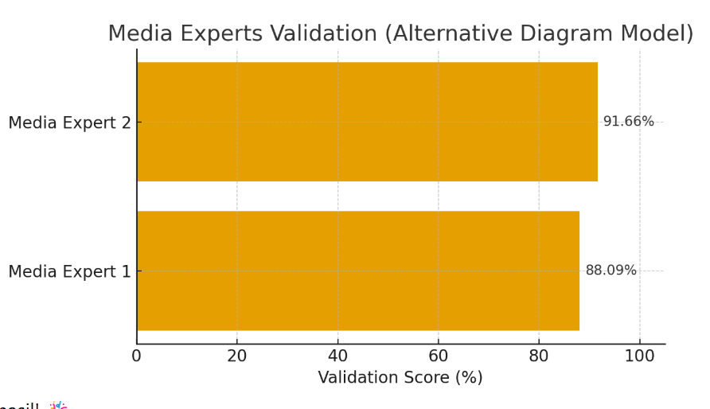
Figure 1. Validation Scores of Media Experts (Original Data)

The figure confirms that both media evaluators rated the application highly, indicating strong technical and design feasibility. The high scores demonstrate that the multimedia integration was coherent, navigable, and visually consistent.

3.4 Implementation Phase
The implementation phase consisted of two trials designed to assess the practicality and user experience of the multimedia application. The small-scale trial involved ten Grade X students, followed by a large-scale implementation involving thirty students. During both trials, students accessed the application via their smartphones during class sessions. Observational data revealed that students were immediately engaged by the multimedia interface. Many began exploring the sections autonomously, replaying video explanations and examining diagrams in detail. Compared to traditional lessons, students displayed noticeable improvements in attention span, curiosity, and conceptual clarity.
The large-scale implementation confirmed these findings. Students navigated the application independently and collaboratively, often discussing the content with peers. They interacted frequently with the quiz component, revisiting content after encountering incorrect answers. Several students commented verbally that the explanations were clearer and easier to follow than in textbook-based lessons. Teachers also observed a significant reduction in off-task behavior and reported a higher concentration level across the classroom.
To illustrate the validation from material experts, the following figure presents the bar chart derived from original data.
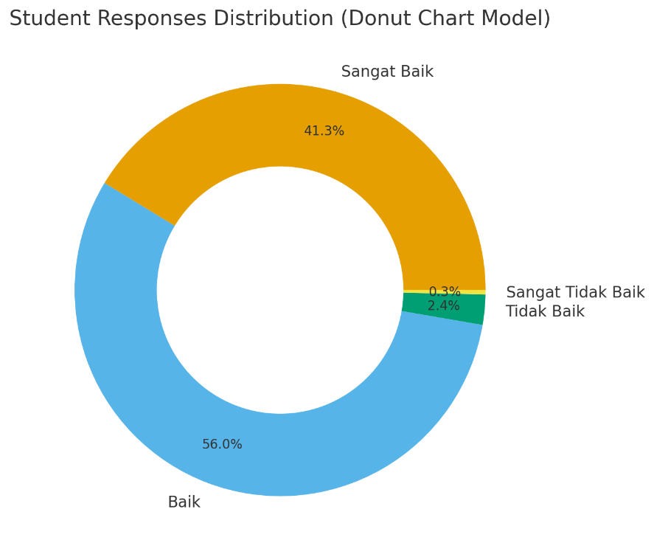

Figure 2. Validation Scores of Material Experts
The material expert scores show strong agreement regarding the accuracy and curricular alignment of the instructional content. The slightly lower score of the second material expert led to refinements in text clarity and content sequencing.

3.5 Evaluation Phase
The evaluation phase synthesized feedback from experts and students to determine the overall instructional effectiveness of the multimedia application. Student responses were collected using a structured questionnaire distributed after the large-scale implementation. The questionnaire assessed perceptions of content clarity, usefulness, visual appeal, ease of navigation, and motivation. The data revealed a total weighted score of 2,977 out of 3,498 possible points. When converted to percentages, the student response score reached 85.14%, belonging to the “Very Good” category. The distribution of student responses showed that 366 ratings fell under “Sangat Baik,” 496 under “Baik,” 21 under “Tidak Baik,” and only 3 under “Sangat Tidak Baik.”
To represent these findings visually, a pie chart was generated based on the original student response distribution.

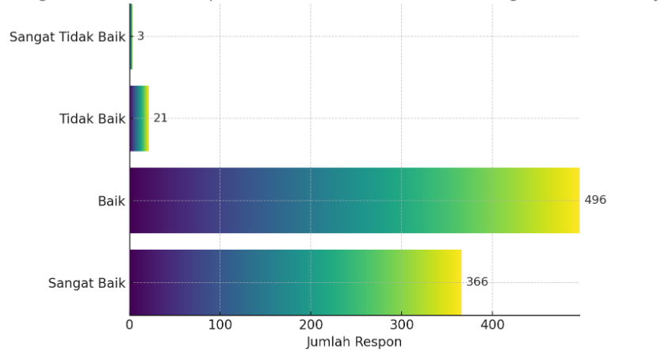
Figure 3. Student Response Distribution

The chart illustrates that an overwhelming majority of student responses were positive, with the combined “Very Good” and “Good” categories dominating the distribution. These results indicate that the multimedia application was well received, effective in enhancing understanding, and motivating for students.
The expert validation results, combined with student feedback and classroom observations, confirm that the multimedia application met the intended goals of feasibility, practicality, and instructional value. The strong positive response suggests that interactive multimedia developed using SAC 3 can be a viable solution for supporting complex conceptual learning in Informatics, especially in contexts where traditional instructional methods fall short.

4. DISCUSSION
The findings of this research demonstrate that the interactive multimedia learning application developed using Smart Apps Creator (SAC 3) effectively addresses fundamental instructional challenges in teaching Computer Systems to Grade X students. The discussion below interprets these results in light of existing literature, multimedia learning theory, and the broader context of Informatics education in Indonesia. Throughout the analysis, it becomes evident that the integration of interactive multimedia strengthens conceptual understanding, enhances student motivation, and aligns with ongoing curricular reforms advocating digital literacy and student-centered learning.
The first major implication of the results relates to students’ improved conceptual clarity. Prior to the intervention, students struggled with abstract concepts such as CPU functionality, memory hierarchy, and the distinction between hardware, software, and brainware. This difficulty is consistent with findings from previous studies indicating that learners often experience cognitive overload when processing highly abstract technological information without adequate visual or interactive support (Yaumi, 2018; Pristiwanti et al., 2022). The multimedia application addressed this issue through visual representations, layered explanations, and audiovisual demonstrations that scaffolded understanding. According to Mayer’s Multimedia Learning Theory, meaningful learning occurs when students engage with information through dual channels—visual and auditory—which reduces intrinsic cognitive load and promotes deeper processing (Mayer, 2021). The improved student comprehension observed during implementation supports this principle. The ability to replay animations, examine diagrams, and reread explanations allowed students to control the pace of their learning and reinforce understanding through repeated exposure.
The positive validation results from media and material experts also affirm the pedagogical and technical soundness of the multimedia application. The high ratings in usability, visual consistency, and content accuracy demonstrate alignment with established best practices in educational media development. These outcomes resonate with research suggesting that well-designed multimedia enhances both cognitive efficiency and learner motivation when the interface is intuitive, aesthetically coherent, and free from unnecessary distractions (Chen et al., 2018; Karlinda, 2021). The iterative refinement process—guided by expert feedback—helped ensure that the application met these standards. For instance, improvements in text readability, color contrast, and icon placement strengthened the usability and instructional clarity of the final product.
Another important aspect highlighted by the findings is the role of interactivity in fostering student engagement. During both trials, students exhibited significantly higher levels of attention and participation than typically observed in conventional lessons. The interactive elements—such as touch-based navigation and responsive quizzes—encouraged students to explore content autonomously and provided immediate feedback that supported self-regulated learning. These outcomes align with contemporary studies asserting that interactivity enhances learner agency, motivation, and comprehension by allowing students to actively construct knowledge rather than passively receive information (Mustafa et al., 2023; Saputra et al., 2023). The capacity for students to revisit content and validate their own understanding through quizzes contributes to metacognitive awareness, which is essential for long-term learning.
The third significant implication relates to the contextual suitability of SAC-based multimedia in Indonesian secondary schools. Many schools operate with limited technological resources and inconsistent internet connectivity, creating barriers to the adoption of many digital learning platforms. The offline functionality of SAC 3, combined with the widespread availability of Android smartphones among students, makes this approach practical and scalable. This study demonstrates that meaningful technology-enhanced learning does not require sophisticated hardware but relies instead on pedagogically sound design and accessible tools. Such an approach aligns with the TIK untuk Pendidikan initiatives that emphasize equitable and context-responsive integration of technology into Indonesian classrooms (Wahyono et al., 2021). The feasibility of the application within the school’s existing infrastructure suggests significant potential for broader dissemination and replication in similar educational environments.
The strong positive responses from students further emphasize the motivational value of multimedia learning materials. Students' reactions, as shown by the overwhelmingly positive ratings in the evaluation phase, suggest that multimedia enhances not only understanding but also enjoyment and engagement. These findings echo a considerable body of literature indicating that emotionally engaging multimedia environments promote intrinsic motivation, which in turn supports persistence, deeper learning, and improved performance (Forsyth et al., 2018; Kong et al., 2022). The students’ preference for animated explanations and video demonstrations reveals their inclination toward dynamic learning experiences rather than static textual resources. This shift underscores the necessity for educators to adapt instructional strategies to contemporary learner profiles, who are increasingly accustomed to visual and interactive digital environments.
Furthermore, the teacher’s observation of reduced off-task behavior during the use of the multimedia application reinforces the assertion that interactive digital tools can reshape classroom dynamics. By providing differentiated pathways for exploration, multimedia applications accommodate diverse learning preferences and allow students to engage according to their individual cognitive styles. In classrooms where traditional teaching methods are predominantly text-based and lecture-driven, such differentiation is often absent. This research demonstrates that multimedia can help bridge this gap by providing multimodal access to content that supports a wider range of learners.
The results also have implications for teacher professional development. The use of SAC 3 in this study demonstrates that multimedia development does not require advanced programming skills. Teachers can leverage accessible authoring tools to design customized digital resources tailored to their students’ needs. This capacity empowers teachers as digital creators rather than mere users of technology, aligning with global trends in pedagogical innovation where teachers are encouraged to co-create learning environments using technology (Voogt & Roblin, 2019). As the Indonesian government continues to emphasize digital literacy and computational thinking in its national curriculum, empowering teachers to design digital learning resources becomes an essential strategy for sustainable implementation.
An additional implication relates to curriculum alignment. The multimedia application was constructed based on core concepts outlined in the national Informatics curriculum, ensuring its relevance and instructional coherence. The positive material validation scores confirm that the content not only adhered to curriculum standards but also deepened conceptual understanding by presenting layered explanations and visualizations. This coherence is crucial because teaching materials must not only be engaging but also pedagogically accurate and aligned with educational standards. The application’s ability to translate national curriculum goals into learner-centered digital experiences demonstrates its potential as a model for curriculum-based media development.
Despite the strong results, certain limitations must be acknowledged. Expert feedback suggested refining specific explanations and reorganizing some content sequences, indicating that the initial design did not fully optimize conceptual flow. Moreover, while the student response data were highly positive, the study did not include pre- and post-tests to measure objective learning gains. The evaluation focused primarily on perception and feasibility rather than quantifying academic improvement. The absence of such measures limits the extent to which conclusions about learning performance can be generalized. Future research could incorporate controlled experimental designs or quasi-experimental comparisons to evaluate learning outcomes more rigorously.
Another limitation concerns the scope of the target population. The study involved students from one school in a rural region of Indonesia, which may limit generalizability to urban schools or schools with different technological conditions. Although the multimedia application performed well in this context, its usability and effectiveness may vary in environments with different student digital literacy levels, teacher capacities, or school infrastructure.
Nevertheless, the strengths of the study provide valuable insights into the future direction of Informatics education. The use of accessible tools such as SAC 3 enables schools to create customized digital learning solutions that support curriculum implementation and address local learning needs. The success of the multimedia application suggests that such tools can be integrated into national strategies for improving digital literacy and computational thinking. Moreover, the combination of multimedia elements aligns well with the nature of Informatics, which requires learners to understand both conceptual systems and practical interactions between hardware and software.
In conclusion, the discussion underscores that interactive multimedia—when systematically developed through the ADDIE model and grounded in contemporary multimedia learning principles—offers a powerful means of supporting abstract conceptual learning in secondary Informatics education. The SAC-based multimedia application developed in this study effectively addressed students’ learning difficulties, increased motivation, enhanced classroom engagement, and aligned with curricular objectives. These insights contribute to the growing body of evidence advocating for scalable, low-barrier digital learning tools that empower both teachers and students in the era of digital transformation.

5. CONCLUSION
The development and evaluation of an interactive multimedia learning application using Smart Apps Creator (SAC 3) for the Computer Systems topic in Grade X Informatics demonstrated that multimedia-enhanced instruction effectively addresses the key learning challenges encountered in traditional classroom settings. The integration of visual, auditory, and interactive elements succeeded in transforming abstract concepts into more concrete and comprehensible representations, leading to improved student engagement and understanding. The systematic application of the ADDIE model ensured that each phase of development was grounded in learner needs, instructional goals, and iterative refinement through expert validation.
Results from media and material experts indicated that the multimedia application achieved high levels of feasibility, validity, and usability. Their evaluations affirmed that the instructional content was accurate, aligned with curriculum standards, and presented coherently. Students’ responses during classroom implementation further supported the pedagogical effectiveness of the media. Learners demonstrated increased motivation, stronger focus, and more active participation when interacting with the application. The overwhelmingly positive perception data—supported by a strong weighted score of 85.14%—indicate that the multimedia design provided a meaningful and enjoyable learning experience.
The findings also reveal broader implications for Informatics education in Indonesia. The study highlights the potential of accessible digital authoring tools like SAC 3 to empower teachers to design context-responsive instructional innovations without requiring advanced technical expertise. Moreover, the ability to run the application offline addresses infrastructural limitations in schools with unstable internet access, making the solution scalable and adaptable to various learning environments. The results therefore align with national efforts to strengthen digital literacy and computational thinking across secondary education.
Despite these promising outcomes, the study acknowledges certain limitations, including the absence of experimental measurements of learning gains and the restricted sample limited to a single school. Future research should explore integrating pre- and post-assessments, implementing comparative studies, and expanding deployment across diverse school contexts to examine generalizability and long-term impact.
In conclusion, this research demonstrates that interactive multimedia developed through a systematic instructional design process offers a viable and effective strategy for enhancing students’ conceptual understanding in Informatics. By providing intuitive, engaging, and curriculum-aligned digital learning experiences, such multimedia tools can play a pivotal role in modernizing instructional practices and supporting Indonesia’s broader digital education agenda. The success of the SAC 3-based application underscores the importance of continued innovation in educational technology and highlights opportunities for future development, teacher empowerment, and scalable integration into the Informatics curriculum.

REFERENCES

Aldoobie, N. (2015). ADDIE model. American International Journal of Contemporary Research, 5(6), 68–72.
Azizah, K. (2020). Pengembangan media pembelajaran interaktif menggunakan Smart Apps Creator. Jurnal Pendidikan Informatika, 4(2), 112–123.*
Chen, C.-H., Huang, C.-Y., & Liu, M. (2018). A review of learning theories applied in game-based learning studies. Computers in Human Behavior, 87, 50–62. https://doi.org/10.1016/j.chb.2018.05.012
Forsyth, D., Waller, J., & Boettcher, J. (2018). Media-rich learning environments and student engagement. Educational Technology Research and Development, 66(5), 1127–1146. https://doi.org/10.1007/s11423-018-9586-2
Karlinda, K. (2021). The effectiveness of SAC-based multimedia in improving students’ comprehension. International Journal of Interactive Mobile Technologies, 15(8), 89–103.* https://doi.org/10.3991/ijim.v15i08.20745
Kong, S. C., Chiu, M. M., & Lai, M. (2022). Digital learning and computational thinking: A systematic review. Computers & Education, 182, 104468. https://doi.org/10.1016/j.compedu.2022.104468
Mayer, R. E. (2021). Multimedia learning (3rd ed.). Cambridge University Press. https://doi.org/10.1017/9781108859012
Molenda, M. (2015). In search of the elusive ADDIE model. Performance Improvement, 54(2), 40–42. https://doi.org/10.1002/pfi.21461
Mustafa, N., Suryani, A., & Wahyudi, R. (2023). Interactive multimedia for enhancing conceptual understanding: A meta-analysis. Education and Information Technologies, 28, 3057–3077. https://doi.org/10.1007/s10639-022-11389-1
Nurhayati, N., & Cahyono, H. (2019). Validitas instrumen pembelajaran berbasis multimedia. Jurnal Evaluasi Pendidikan, 10(1), 44–54.
Pristiwanti, D., Hasanah, U., & Fitriani, N. (2022). Students’ learning challenges in technology subjects. Journal of Technical and Vocational Education, 12(3), 285–296.
Saputra, A., Ramadhani, S., & Putra, Y. (2023). Effects of interactive multimedia on student engagement: A quasi-experiment. Education and Information Technologies, 28, 1785–1801. https://doi.org/10.1007/s10639-022-11285-8
Sugiyono. (2019). Metode penelitian dan pengembangan (R&D). Alfabeta.
van Deursen, A. J., & Helsper, E. J. (2018). The second-level digital divide: Differences in people’s online skills. Communication Research, 45(5), 719–740. https://doi.org/10.1177/0093650217714362
Voogt, J., & Roblin, N. P. (2019). A comparative analysis of international frameworks for 21st century skills. Journal of Curriculum Studies, 51(3), 329–353. https://doi.org/10.1080/00220272.2018.1447846
Wahyono, P., Husamah, H., & Masruri, M. S. (2021). Teacher readiness in implementing Informatics Curriculum. Journal of Education and Learning, 15(4), 512–523. https://doi.org/10.11591/edulearn.v15i4.20745
Yaumi, M. (2018). Media dan teknologi pembelajaran. Kencana.

