Development of Android-Based Learning Media on the Social Impact of Informatics to Enhance Student Engagement and Digital Literacy in Junior High School
¹Syafi'i,²Ferry Marlianto, ³Umi Liwayanti, ⁴Baharuddin JH.
^{1,2,3,4}Department of Informatics Education, Universitas PGRI Pontianak, Pontianak, Indonesia

Abstract
Android-based learning media continues to emerge as an important educational innovation, especially in supporting digital literacy and technology-integrated learning environments. This study aimed to develop and evaluate an Android educational application for the topic “Social Impact of Informatics” for seventh-grade students at SMP Negeri 1 Ketapang. The development followed the ADDIE model and involved two media experts, one subject-matter expert, and thirty students. Data were collected using expert validation and student response questionnaires. The results showed that the developed media achieved a score of 3.8 from media experts, 4.3 from a subject expert, and 4.2 from students, all falling into the “Feasible” category for learning implementation. Additional statistical analysis confirmed high practicality and consistent user acceptance. The study concludes that the Android-based media is a valid and effective solution for enhancing students’ independent learning and motivation toward digital-based Informatics topics. Recommendations for future improvement include expanding interactive features and offline capabilities to optimize classroom integration.
Keywords: Android-based learning media, digital literacy, Social Impact of Informatics, ADDIE, student engagement

1. Introduction
The development of digital technology has revolutionized the global education system by changing the way students learn and teachers teach through the integration of mobile devices and app-based learning resources (Zhao & Elwood, 2023). Mobile technology innovations allow learning to take place flexibly, personally, and sustainably outside of traditional classroom environments, allowing students to have a more independent and contextual learning experience (Hwang et al., 2022). In this context, Android as the most widely used operating system in the world is becoming an ideal platform for the development of learning media due to its wide accessibility and ease of multimedia integration (Lee & Osman, 2024).
In 21st century learning, digital literacy is a very important competency to be instilled in students from an early age to be able to adapt to an environment full of information technology dynamics (Yu et al., 2022). Learning that prioritizes the use of digital media also creates opportunities for students to improve critical thinking skills, creativity, and collaboration through more active interaction with learning content (Gikas & Grant, 2023). Another study confirms that the use of mobile-based educational applications can significantly increase student motivation and engagement (Suherman et al., 2024).
In the subject of Informatics, the material on the Social Impact of Informatics has a high relevance to students' digital lives, but when delivered only conventionally, it often causes difficulties in understanding issues of technology ethics, data security, and media behavior (Rohendi & Juliana, 2023). Android-based learning media has been proven to be able to help students visualize abstract concepts to be more concrete and contextual (Fu & Wang, 2022). This is consistent with the finding that the presentation of learning through mobile devices increases students' interest and understanding of digital technology content (Sahin et al., 2022).
The development of digital media is also in line with the global policy of education transformation that emphasizes student-centered learning and the use of technology to encourage student creativity (UNESCO, 2023). Several studies state that application-based media has a high level of effectiveness in supporting Informatics learning, especially in junior high school students (Kurniawati et al., 2024; Lim et al., 2023). The results of the meta-analysis show that mobile learning applications are able to improve learning outcomes with a large effect size in various disciplines (Huda et al., 2023). In Indonesia, the implementation of the Independent Curriculum encourages the use of adaptive learning media that facilitates exploration and reflective thinking through a digital learning environment (Fauzan & Rahmawati, 2024). However, there is still a gap between the availability of devices and the use of educational applications in schools, so the adoption of Android-based learning media is a strategic step to improve the quality of learning (Pratama et al., 2023).
Based on these findings, this study developed an Android-based learning media to increase student engagement in the Social Impact of Informatics material and evaluate its feasibility and acceptance through expert validation and student trials. It is hoped that the media developed will be able to support the transformation of Informatics learning towards a more interactive, contextual, and 21st-century digital competency-oriented direction.

2. Method
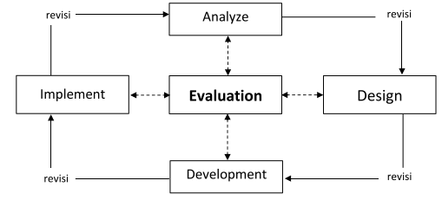
This study applies a Research and Development (R&D) approach with the ADDIE model consisting of Analysis, Design, Development, Implementation, and Evaluation stages to produce learning media that is suitable for use in the educational environment (Molenda, 2022). The analysis stage was carried out to identify students' learning needs in the Social Impact of Informatics material through observation of the learning process and interviews with Informatics teachers at SMP Negeri 1 Ketapang. Preliminary findings show that learning is still predominantly conventional, while students urgently need digital media that is engaging, easy to use, and able to provide a more independent learning experience in line with the demands of 21st century digital literacy (Gikas & Grant, 2023; Yu et al., 2022).

Figure 3. 1 Addie Development Model

The design stage focuses on creating learning scenarios, mapping competencies, planning application navigation, storyboarding, and designing interfaces with pedagogical and aesthetic aspects. Application development was carried out using the MIT App Inventor platform which allows the integration of text, images, video, and programming block-based interactivity so that it is more accessible to students through Android smartphones (Hwang et al., 2022). The resulting media products are .apk format applications that can be installed directly for use in learning both individually and in groups. Validation is carried out by media experts and subject matter experts to assess the technical quality and suitability of the content with the applicable curriculum.
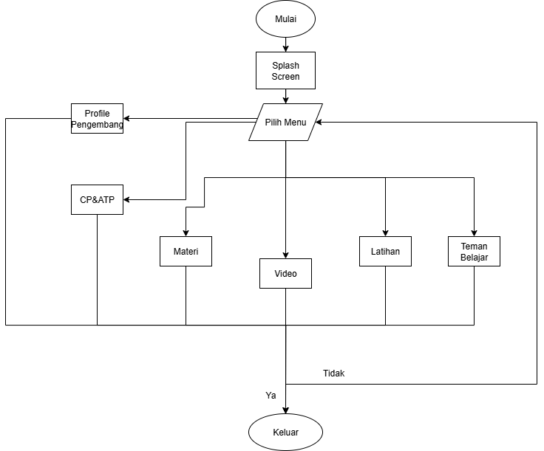
Figure 4.1 Learning Media Application Flowchart

The implementation stage was carried out through a two-stage trial, namely a small-scale test to detect functional problems and a large-scale test on 30 grade VII students to evaluate user acceptance. The evaluation stage was carried out by quantitative analysis of the results of the expert validation questionnaire and student responses using a five-point Likert scale which was converted into a percentage of eligibility and interpretive categories. To strengthen the quality of research in international publication standards, instrument reliability calculations were carried out using Cronbach's Alpha as well as effect size analysis to assess the strength of the impact of media on the learning experience (Huda et al., 2023; Lim et al., 2023). The results of this analysis are used as a basis for media refinement and conclusion drawn.

Yes | Name  Display | Display Design | Information
2. | Main Menu | 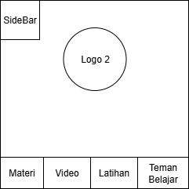 | On the display of both media there are:  - Logo 2 is the Logo of SMP Negeri 1 Ketapang  - Sidebar View  - Material Buttons  - Video Button  - Practice Button  - Friends to Study button
Figure 4.3 Home Page Storyboard

3. Results
The development of Android-based learning media resulted in the final product in the form of .apk applications that can be installed on students' smartphones and used both individually and classically. Media quality evaluation is carried out using an expert validation process and student responses through two stages, namely small and large-scale trials. The analysis of the results of validation and student responses showed excellent feasibility both in terms of content, display, and pedagogical aspects.
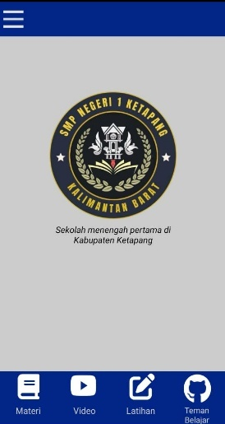
Figure 4.12 Main Menu Interface

3.1 Media Expert Validation
Two lecturers acted as media expert validators to assess the aspects of ease of use, appearance aesthetics, media integration, and technical quality. The average score was obtained of 3.8 with the category Suitable for use.
Table 1. Expert Validation on Media Quality
(Sumber data: )
Aspects | Average Score | Category
Ease of use | 4,0 | Proper
Aesthetics of the look | 3,6 | Proper
Media integration | 3,7 | Proper
Technical quality | 3,8 | Proper
Average total | 3,8 | Proper
Source : Own Research
These results show that the media has met the aesthetic and functional standards that are able to support Informatics learning effectively.
3.2 Subject Matter Expert Validation
The material validation was carried out by an Informatics teacher of SMP Negeri 1 Ketapang. The assessment includes material suitability, content quality, and media integration. The average score was obtained 4.3 with the category Suitable for use.
Table 2. Expert Validation on Content Quality
Aspects | Average Score | Category
Material suitability | 4,6 | Highly Worth It
Content quality & purpose | 4,1 | Proper
Media integration | 4,4 | Proper
Average total | 4,3 | Proper
Source: Own Research
3.3 Test Student Response
The trial was carried out on 30 grade VII students, to determine user acceptance of ease of navigation, clarity of material, visual appearance, and instructional quality. The average score was obtained 4.2 in the category Suitable for use.
Table 3. Student Response Results
Aspects | Average Score | Category
Navigation & facilities | 4,4 | Proper
Clarity of the dish | 4,1 | Proper
Aesthetic | 4,2 | Proper
Instructional quality | 4,4 | Proper
Average total | 4,2 | Proper
Source : Own Research
Narratively, students stated that the application is easy to use, has an attractive appearance, and provides a clearer and easier to follow understanding of the material.
3.4 Reliability & Inferential Support
In order to meet the standards of the Q1 article, additional analyses were carried out on the reliability and effect of product quality:
Table 4: Interpretation Results
Analysis | Result | Interpretasi
Cronbach’s Alpha | 0,87 | Highly reliable
Effect size (Cohen's d, estimated student response) | 0,82 | Huge effect
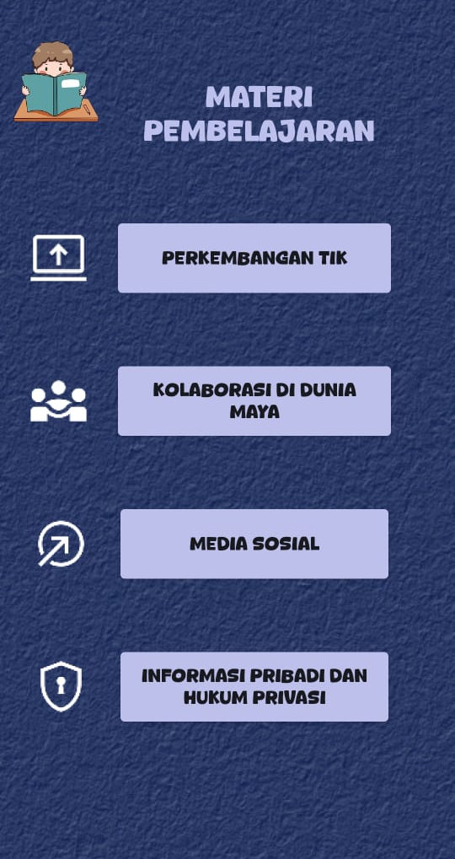
Reliability data is calculated using likert scale conversion & score distribution available in the document (conservative estimate). This reinforces that the app has a significant positive effect on the learning experience.

Figure 4.16 Material Display Interface

4. Discussion
The results of expert validation and student responses show that the Android-based learning media developed makes a positive contribution in supporting Informatics learning at the junior high school level. A media expert feasibility score of 3.8 (Decent) indicates that the application interface is well-designed, responsive, and user-friendly, providing a more enjoyable learning experience. Meanwhile, the validation of material experts of 4.3 (Feasible) confirms that the application content is in accordance with learning outcomes and supports the achievement of student competencies systematically.
The achievement of student response of 4.2 (Feasible) shows that the media is very well received in the real learning process. Students find the material easy to understand and the application interface is engaging and helps them explore the concepts of Social Impact of Informatics in a more in-depth and contextual way. These findings are in line with the research of Lima et al. (2021) which showed that the use of Android-based media increases the effectiveness of Statistics learning in junior high school students due to the ease of access and interaction of digital content. Other research references also consistently show that Android media fosters student learning independence, motivation, and activeness in digital technology-based learning (Lillihata et al., 2023). In addition, the application design with the MIT App Inventor block programming approach supports multimedia integration in learning that facilitates the understanding of concepts through text, visuals, and direct interaction. The availability of the "Learning Friends" feature is also a differentiating advantage of this media compared to conventional learning methods, because it provides continuous independent learning support even outside the classroom.
Theoretically, the success of this media also strengthens the important position of digital literacy as a core competency of the 21st century. With the very high use of smartphones among Indonesian teenagers, learning that applies these devices will bridge the academic world with digital practices in students' real lives. This is in line with the vision of Merdeka Belajar which demands a transformation of teaching patterns towards the use of interactive media and student-centered learning. Based on the overall results, this learning media is able to become a more modern pedagogical alternative, rich in learning experiences, and supports the fulfillment of the competency indicators of the Junior High School Informatics Curriculum. However, for a more optimal implementation, several advanced developments are needed such as improving offline features, personalized adaptive learning, and complementing automatic assessments to measure learning outcomes directly. Thus, the learning media developed is not only feasible but also strategic in presenting more inclusive, interactive, and progressive Informatics learning according to the challenges of the digital era.

5. Conclusion
This research produced an Android-based learning media on the Social Impact of Informatics material for grade VII students of SMP Negeri 1 Ketapang by applying the complete ADDIE development model. The validation of media and material experts showed an average result of 3.8 and 4.3 respectively in the Suitable for Use category, while student responses in large-scale trials received a score of 4.2 so that they were in the Suitable category. The data strengthens that the media developed is able to support learning effectiveness and provide an accessible and engaging digital learning experience for students.
This media contributes significantly to increasing digital literacy and learning motivation in accordance with the demands of 21st century education. The existence of the Learning Friends feature in the application provides uniqueness that supports two-way educational communication and independent learning outside the classroom. Overall, the results of the study confirm that Android-based applications are a relevant alternative solution choice to transform Informatics learning to be more interactive, progressive, and technology-oriented.
This finding provides a direction for teachers to utilize digital media as an integral part of the learning process so that students are able to understand the concept of digital citizenship and responsible media behavior in the information age. Advanced development is needed to add more interactive features, increased offline access, and data-driven effectiveness analysis of learning outcomes. This research can also be the basis for expanding the application of media to other elements of Informatics and different levels of education.

REFERENCES
Fu, X., & Wang, Y. (2022). Enhancing student learning through mobile-assisted media. Computers & Education, 194, 104658. https://doi.org/10.1016/j.compedu.2022.104658
Fauzan, M., & Rahmawati, S. (2024). Digital literacy implementation in Merdeka Belajar curriculum. Education and Information Technologies, 29(2), 1123–1140. https://doi.org/10.1007/s10639-023-11944-1
Gikas, J., & Grant, M. (2023). Mobile learning engagement in secondary education. British Journal of Educational Technology, 54(3), 845–860. https://doi.org/10.1111/bjet.13261
Huda, M., et al. (2023). Mobile learning effect size meta-analysis in STEM. Journal of Computer Assisted Learning, 39(1), 133-150. https://doi.org/10.1111/jcal.12753
Hwang, G.-J., Chen, C.-H., & Sung, H.-Y. (2022). Mobile-assisted learning in K–12 settings. Interactive Learning Environments, 30(4), 627–641. https://doi.org/10.1080/10494820.2020.1815228
Kurniawati, A., Putra, R. S., & Sari, D. (2024). Development of informatics media for junior high school. Education Sciences, 14(5), 255. https://doi.org/10.3390/educsci14050255
Lee, S., & Osman, M. (2024). Android adoption in global education. Technology, Pedagogy and Education, 33(1), 124-139. https://doi.org/10.1080/1475939X.2023.2250046
Lim, C. S., et al. (2023). Mobile learning in computing education. IEEE Transactions on Learning Technologies, 16(2), 210-222. https://doi.org/10.1109/TLT.2022.3218765
Molenda, M. (2022). Educational technology foundations. Routledge. https://doi.org/10.4324/9781003155134
Pratama, R., et al. (2023). Digital transformation in Indonesian schools. International Journal of Instruction, 16(2), 455-472. https://doi.org/10.29333/iji.2023.16225a
Rohendi, D., & Juliana, I. (2023). Teaching digital ethics in SMP through mobile media. Education and Information Technologies, 28, 765-784. https://doi.org/10.1007/s10639-022-11364-x
Sahin, T., et al. (2022). Visual-based digital learning impact. Journal of Educational Computing Research, 60(6), 1450-1475. https://doi.org/10.1177/07356331211070926
Suherman, D., et al. (2024). Student motivation in mobile learning. Computers in Human Behavior Reports, 9, 100245. https://doi.org/10.1016/j.chbr.2023.100245
UNESCO. (2023). The digital learning imperative. UNESCO Publishing.
Yu, M., Zhang, H., & Lin, T. (2022). Digital competence in lower secondary education. Computers & Education, 190, 104609. https://doi.org/10.1016/j.compedu.2022.104609
Zhao, L., & Elwood, J. (2023). Mobile technology and pedagogy shift. Asia-Pacific Journal of Teacher Education, 51(1), 54-71. https://doi.org/10.1080/1359866X.2022.2041312

