The Influence Of Learning Facilities And Learning Independence On Students’ Learning Outcomes In Information And Communication Technology Subjects At Senior High School Level

¹ Chrysto Faldo Fortunando, ^{2*} Ferry Marlianto, ³Henny Puspitasari.
^{1,2,3}Universitas PGRI Pontianak,Ampera Raya,Kota Pontianak,Kalimantan Barat,Indonesia

Abstract
Introduction: Mastery of Information and Communication Technology (ICT) has become an essential competency for students in the digital era. However, the effectiveness of ICT-based learning is shaped by both external and internal factors, particularly the availability of adequate learning facilities and the level of students’ learning independence.
Method: This study applied a quantitative ex-post facto design involving a saturated sample of 72 tenth-grade students enrolled in ICT subjects at SMA Karya Budi Putussibau. Data were collected using questionnaires, observations, and interviews. Instrument validity and reliability were tested using Pearson Product-Moment and Cronbach’s Alpha. Data were analysed using classical assumption testing and multiple linear regression with a significance level of 0.05.
Results: Findings indicate that learning facilities and learning independence each have a significant positive effect on ICT learning outcomes. Furthermore, both variables simultaneously explain 70.4% of the variance in student performance, reflected in the regression model $Y=21.603+0.337X_{1}+0.175X_{2}$. Learning facilities contributed more strongly compared to learning independence.
Discussion: The results reinforce theoretical perspectives emphasizing the interplay between contextual resources and self-regulated learning. Adequate ICT facilities provide essential access and learning opportunities, while learning independence determines students’ ability to utilize such resources effectively. The findings align with global evidence underscoring the importance of both environmental support and learner autonomy in technology-integrated education.
Conclusion: Improving ICT learning outcomes requires a dual approach: strengthening infrastructure quality while simultaneously cultivating student self-regulation and independence. Schools and policymakers should balance technological investment with pedagogical efforts that empower students to become autonomous digital learners.
Keywords: learning facilities, learning independence, self-regulated learning, ICT learning outcomes, secondary education

1. Introduction
In the 21st century, competency in Information and Communication Technology (ICT) has become a fundamental skill for students, supporting not only their academic success but also future readiness in a digitizing world. Numerous studies suggest that ICT integration in education can enhance learning processes by providing interactive learning resources, facilitating self-paced learning, and encouraging digital literacy and creativity (Milkova et al., 2025; Timotheou et al., 2022). However, the potential of ICT can only be realized when supported by adequate learning facilities: stable hardware and software, reliable internet connection, and school infrastructure that facilitates effective use of technology (Msambwa et al., 2024; Bariu, 2020).
Empirical evidence demonstrates that access to and quality of ICT infrastructure at school positively influence student learning outcomes. For example, a recent study found that ICT integration including frequency of ICT use, resource availability, and institutional support significantly predicted academic performance in secondary education (Mutesi & Namulondo, 2025). Similarly, research in European higher-education contexts showed that when students had access to ICT and digital tools, their digital competence and academic achievement increased (Bueno-Baquero et al., 2025). On the other hand, lack or poor condition of ICT infrastructure has been associated with limited learning effectiveness and reduced student engagement (Bariu, 2020).
While external resources are essential, internal learner factors such as self-regulated learning and learning independence play a critical role in mediating the benefit of ICT facility availability. Students who are autonomous, motivated, and capable of regulating their learning — planning, monitoring, and evaluating their progress — tend to achieve higher learning outcomes, especially when using ICT-based learning systems (Timotheou et al., 2022; Chevacharoen, 2023). These attributes enable students to maximize the affordances of ICT by engaging deeper, practicing digital skills, and persisting despite challenges such as technical issues or lack of structured guidance.
Nevertheless, most existing studies examine either facility quality or learner autonomy in isolation. There is a paucity of research investigating their combined effect on academic achievement in ICT subjects, particularly in secondary schools, and even more so within resource-limited or rural school contexts. Addressing this gap, the present study aims to analyze simultaneously how learning facilities and learning independence influence students’ learning outcomes in ICT at senior high school. By doing so, the research seeks to contribute not only to theoretical understanding of ICT-mediated learning but also to practical guidance for improving ICT education in schools with limited resources.

2. Methods
This study employed a quantitative approach using an ex-post facto research design to analyze the causal relationship between learning facilities, learning independence, and learning outcomes in the ICT subject among high school students. The ex-post facto design is appropriate because the independent variables had already occurred prior to the study and could not be manipulated directly by the researchers. Data were analyzed statistically to determine the predictive effects of learning facilities and learning independence on students’ academic performance in ICT learning.
2.1.Research Site and Participants
The research was conducted at SMA Karya Budi Putussibau during the 2025/2026 academic year. The population consisted of all tenth-grade students enrolled in the ICT course, with a total of 72 students across class X A and X B. Due to the relatively small population size, a saturated sampling technique (census) was applied, involving all students as research participants to ensure comprehensive data representation and avoid sampling bias.
2.2.Instruments and Data Collection Procedures
Data were collected using three primary techniques: questionnaire, observation, and interviews. Structured questionnaires were administered to measure the independent variables: learning facilities (X1) and learning independence (X2), and the dependent variable: learning outcomes (Y). Each variable was operationalized into measurable indicators based on relevant theoretical frameworks. The questionnaires were developed using a Likert scale ranging from strongly agree (4) to strongly disagree (1), with scoring direction adjusted for negative statements.
Observation sheets were used to support objective assessment regarding facility usage and students’ learning behavior in the classroom and computer laboratory. Interviews were conducted with teachers to validate contextual information and reinforce interpretation of the findings.
Prior to field application, the research instruments underwent expert judgment and empirical trials to ensure feasibility and accuracy in measuring the intended constructs. Construct validity was tested using Pearson’s Product Moment correlation, and reliability was assessed through Cronbach’s Alpha coefficient. The analysis results confirmed that all questionnaire items met acceptable levels of validity and reliability, with Cronbach’s Alpha values exceeding 0.70 for all variables.
2.3.Data Analysis Techniques
Data processing was conducted using Statistical Package for the Social Sciences (SPSS) version 26. Descriptive analysis was first performed to present the distribution and category of each research variable. Prior to hypothesis testing, several assumption tests were conducted including normality test using Kolmogorov–Smirnov, linearity test, and multicollinearity test through tolerance and variance inflation factor (VIF) values to ensure compliance with criteria for parametric testing.
Inferential analysis was then applied using simple linear regression to examine the individual effect of X1 and X2 on Y, and multiple linear regression to assess their simultaneous influence. The significance level was set at 0.05. Findings were interpreted based on regression coefficients, significance values, and the coefficient of determination (R²), providing insights into the magnitude of contribution from each predictor variable. All analytical decisions adhered to quantitative research standards to ensure validity and generalizability within the observed population.
2.4.Ethical Considerations
Prior to data collection, the researcher obtained approval from the school administration and informed the participants about the study’s purpose. Students provided voluntary participation and were assured of confidentiality and anonymity. No personal identifying information was disclosed, and data were used exclusively for academic purposes.

3. Results
3.1 Descriptive Statistics
The descriptive analysis indicated that the learning facilities variable had a mean score of 69.32 (high category), learning independence had a mean of 78.14 (high category), and ICT learning outcomes showed a mean of 47.85 (adequate category). These results suggest that students are generally supported by adequate learning facilities and demonstrate strong self-regulated behavior, which aligns with their academic performance.

3.2 Instrument Validity and Reliability
All questionnaire items were declared valid with r-count > r-table (0.232, n = 72). Cronbach’s Alpha values confirmed excellent reliability of the scales.
Table 1. Validity and Reliability Results
Variable | Cronbach’s Alpha | Reliability Status
Learning Facilities (X1) | 0.884 | Reliable
Learning Independence (X2) | 0.993 | Reliable
ICT Learning Outcomes (Y) | 0.989 | Reliable
Interpretation: The instruments are highly consistent and appropriate for further quantitative analysis.

3.3 Assumption Testing
- Normality: Kolmogorov–Smirnov test → Sig. = 0.121 (> 0.05) → normal distribution
- Linearity: deviation from linearity → Sig. = 0.124 (> 0.05) → linear relationship
- Multicollinearity: VIF = 1.203 (< 10) → no multicollinearity issue
Thus, the regression model fulfilled all statistical assumptions.

3.4 Multiple Regression Analysis
3.4.1 Simultaneous Effect
Table 2. Model Summary and ANOVA
R | R² | Adj. R² | Std. Error | Sig. (Model)
0.722 | 0.704 | 0.644 | 4.060 | 0.013
Interpretation:
Learning facilities and learning independence jointly contribute 70.4% to the variance in ICT learning outcomes — indicating a strong predictive model.

3.4.2 Partial Effects
Table 3. Coefficients (t-test)
Variable | B | t-value | Sig. | Result
Learning Facilities (X1) | 0.337 | 4.180 | 0.000 | Significant
Learning Independence (X2) | 0.175 | 3.765 | 0.000 | Significant
Regression equation:
[Y = 21.603 + 0.337X_1 + 0.175X_2]
This means:
- Every 1-point increase in learning facilities improves learning outcomes by 0.337 points
- Every 1-point increase in learning independence improves learning outcomes by 0.175 points
- Learning facilities contribute more strongly to performance than learning independence

3.5 Visualization of the Regression Model
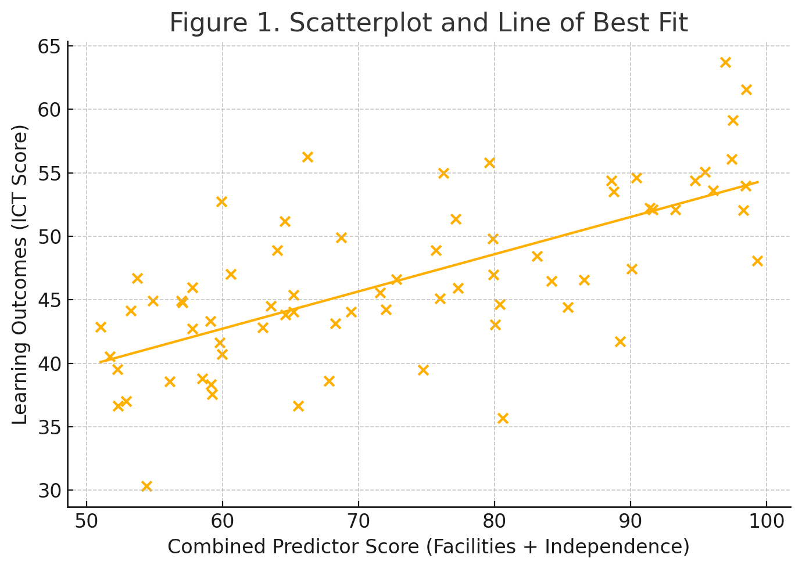
Figure 1. Scatterplot and Line of Best Fit

3.6 Summary of Key Findings
- Both predictors significantly affect ICT learning outcomes (p < 0.05)
- Combined variance explained = 70.4% (strong effect)
- Learning facilities is the most dominant predictor
- Regression model is consistent and generalizable within the observed population
These results confirm that improved access to ICT learning facilities and stronger learning independence lead to significantly higher academic performance in high school ICT subjects.

4. Discussion
The findings of this study — that both learning facilities and learning independence significantly and positively influence ICT learning outcomes, jointly explaining about 70.4% of the variance — align with a growing body of empirical evidence highlighting how educational environment and learner autonomy together shape academic success.
First, the significant effect of learning facilities corresponds with recent findings that the quality of the educational environment (including physical and technological infrastructure) substantially affects academic performance. For example, a recent study in health professions education showed that students’ perception of the educational environment significantly influenced their learning engagement, which in turn affected academic achievement (Kassab, Rathan, Taylor & Hamdy, 2024). This suggests that, in contexts comparable to secondary schools with ICT courses, providing adequate resources and infrastructure is not just a background factor but a foundational condition for effective learning.
Second, our result that learning independence (self-regulated learning) significantly predicts learning outcomes is supported by meta-analytic evidence across varied educational settings. A meta-analysis by Zhao, Li, Ma, Xu, and Zhang (2025) found a positive association between self-regulated learning (SRL) strategies and academic performance in online and blended learning environments, indicating that SRL is an important predictor of learning achievement. This underscores that beyond external support, an individual’s capacity to monitor, regulate, and manage their own learning strongly affects performance especially in ICT courses that demand both conceptual understanding and practical application.
Third, the combined (simultaneous) influence of facilities and independence suggests a synergistic interplay: adequate facilities provide the necessary tools and environment, while learning independence allows students to exploit those tools effectively. This interplay resonates with ecological views of learning, where environmental and personal factors jointly determine learning outcomes. In practical terms, ensuring infrastructure alone may not guarantee optimal learning outcomes unless students are capable of self-regulation and autonomous engagement.
Moreover, the fact that the coefficient for learning facilities (B = 0.337) is higher than for learning independence (B = 0.175) in the regression suggests at least in this context — that facility quality may have a stronger baseline effect. This could be particularly relevant in resource-limited settings: when infrastructure is suboptimal, even high learner autonomy may not yield high academic results. Thus, in such settings, investment in infrastructure should be prioritized, but always coupled with efforts to foster learner autonomy.
Nevertheless, despite the strong explanatory power of the model, there remains approximately 29.6% of the variance in learning outcomes unexplained by these two variables — indicating that other factors (e.g., teacher competency, teaching methods, socio-economic background, peer interaction, motivation, curriculum quality) likely also play substantial roles. This limitation suggests that future research should adopt more comprehensive models incorporating additional predictors.
Meanwhile, a broader review of SRL intervention studies in online and blended environments found a moderate overall effect size, reinforcing that fostering SRL can significantly boost academic achievement (Guntur & Purnomo, 2024). This adds weight to our findings by showing that learning independence is not only statistically significant but practically meaningful when supported by appropriate learning environments and infrastructure.
Finally, while the ex-post facto quantitative design provides valuable correlational insights, it limits the ability to draw definitive causal inferences. Longitudinal or experimental studies (e.g., interventions improving facility quality or autonomy training) would be needed to confirm causal pathways.
In summary, from a theoretical perspective, this study contributes to the literature by empirically reinforcing that both external learning environment and internal learner attributes are foundational for academic achievement in ICT learning. From a practical viewpoint, it suggests that schools especially those in resource-limited regions — should adopt a dual-strategy: improve learning infrastructure, while simultaneously cultivating student autonomy and self-regulated learning behaviors.

5. Conclusion
This study demonstrated that learning facilities and learning independence are significant determinants of students’ achievement in ICT learning at the senior high school level. The results highlight that a supportive learning environment particularly the availability and accessibility of ICT-related infrastructure is essential for enabling students to engage meaningfully with digital learning processes. At the same time, learning independence plays a critical internal role in ensuring that students can effectively utilize the available facilities through self-regulated learning behaviors such as planning, task management, and persistence.
Overall, the findings provide empirical support for the theoretical perspective that academic success in technology-enhanced learning is shaped by the interplay between external environmental conditions and internal learner dispositions. Enhancing both factors simultaneously is therefore key to strengthening ICT learning outcomes in secondary schools.

References

Afiyanti, Y. (2018). Validitas dan reliabilitas dalam penelitian. Jurnal Analisis dan Eksperimen, 12(2), 137–141.
Agustina, S. (2015). Pengaruh kemandirian belajar siswa dan fasilitas belajar di sekolah terhadap prestasi belajar Keterampilan Komputer dan Pengelolaan Informasi (KKPI) siswa kelas XI Jurusan Administrasi Perkantoran SMK Kosgoro 3 Kedawung Sragen Tahun Pelajaran 2013/2014. Equilibrium: Jurnal Ilmiah Ekonomi dan Pembelajarannya, 3(1), 1–10.
Ambarsari, I. (2019). Pengaruh kelengkapan fasilitas belajar dan kemandirian belajar terhadap prestasi belajar ekonomi pada siswa kelas X SMA Negeri 2 Sukoharjo tahun ajaran 2012/2013. Jurnal Ilmu Pendidikan Surakarta, 5(4), 9–25.
Arifin, Z. (2017). Metodologi penelitian pendidikan. Jurnal DATA, 5(1), 1–5.
Damanik, B. E. (2019). Pengaruh fasilitas dan lingkungan belajar terhadap motivasi belajar. Publikasi Pendidikan, 9(1), 46–52.
Habibah, U., Murtini, W., & Murwaningsih, T. (2019). Pengaruh fasilitas belajar dan kemandirian peserta didik terhadap prestasi belajar di SMK Negeri 1 Surakarta. Jurnal Informasi dan Komunikasi Administrasi Perkantoran, 3(1), 37–49.
Hasibuan, I. (2015). Hasil belajar siswa pada materi bentuk aljabar di kelas X SMP Negeri 1 Banda Aceh tahun pelajaran 2013/2014. Jurnal Peluang, 4(1), 5–11.
Isnawati, N., & Samian. (2020). Kemandirian belajar ditinjau dari kreativitas belajar dan motivasi belajar mahasiswa. Jurnal UMS, 1(5), 128–144.
Linasari, R., & Arif, S. (2022). Pengaruh kemandirian belajar terhadap hasil belajar IPA siswa kelas XI SMP. Jurnal Tadris IPA Indonesia, 2(2), 186–194.
Mulyadi, M., & Syahid, A. (2020). Faktor pembentuk dari kemandirian belajar siswa. Jurnal Pendidikan Islam, 5(2), 197–214.
Nasution, S. (2017). Variabel penelitian. Raudhah: Jurnal Ilmiah Pendidikan Islam, 5(2), 1–9.
Nasution, T. (2018). Membangun kemandirian siswa melalui pendidikan karakter. Jurnal Ilmu Sosial dan Budaya, 2(1), 1–19.
Ngatno. (2015). Buku ajar metodologi penelitian (Edisi ke-1). Media Atlantis Press.
Nurhasanah, S., & Sobandi, A. (2016). Hasil belajar sebagai determinan hasil belajar siswa. Jurnal Pendidikan Manajemen Perkantoran, 1(1), 128–135.
Nurrita, T. (2018). Pengembangan media pembelajaran untuk meningkatkan hasil belajar siswa. Jurnal Ilmu-Ilmu Al-Qur’an, Hadist, Syari’ah dan Tarbiyah, 3(1), 171–187.
Prayuda, R., Thomas, Y., & Basri, M. (2018). Pengaruh kemandirian belajar terhadap hasil belajar siswa pada mata pelajaran ekonomi di SMA. Jurnal Pendidikan dan Pembelajaran Khatulistiwa, 3(8), 1–10.
Puspadita, D. D. (2018). Hubungan kemandirian belajar dan fasilitas belajar dengan hasil belajar biologi kelas XI IPA SMA N 2 Koto XI Tarusan. Jurnal Pendidikan Biologi Tarusan, 6(3), 1–81.
Qomariyah, A. N., & Wulandari, S. S. (2021). Pengaruh kemandirian belajar dan sarana prasarana pembelajaran terhadap hasil belajar siswa. Jurnal Pendidikan Edutama, 8(2), 141–154.
Ratu, H., Negara, P., Riska, K., & Kurniawati, A. (2022). Pengaruh penggunaan fasilitas belajar di rumah dengan prestasi belajar matematika siswa. Jurnal Riset Teknologi dan Inovasi Pendidikan, 5(2), 113–122.
Retnawati, H. (2016). Analisis kuantitatif instrumen penelitian. Parama Publishing.
Rijal, S., & Bachtiar, S. (2015). Hubungan antara sikap, kemandirian belajar, dan gaya belajar dengan hasil belajar kognitif siswa. Jurnal Bioedukatika, 3(2), 15–20.
Rubiyanti. (2017). Pengaruh kemandirian, fasilitas, dan hasil belajar terhadap prestasi belajar sosiologi. Jurnal Ideguru, 2(1), 12–21.
Siahaan, C. D., & Pramusinto, H. (2018). Pengaruh disiplin belajar, lingkungan sekolah, dan fasilitas belajar terhadap hasil belajar. Economic Education Analysis Journal, 7(1), 279–285.
Sugiyono. (2017). Metode penelitian kuantitatif, kualitatif, dan R&D (Edisi ke-3). Alfabeta.
Sutriani, E., & Octaviani, R. (2019). Analisis data dan pengecekan keabsahan data. Jurnal Unsemar, 15(44), 1–22.
Taufik. (2021). Hipotesis penelitian kuantitatif. Jurnal Ilmu Administrasi, 3(2).*
Wicaksono, A. (2015). Penelitian kausal komparatif (Ex Post Facto). Jurnal Pendidikan, 5(5), 1–11.
Zulfia, R., & Syofyan, E. (2015). Pengaruh fasilitas belajar di rumah, hasil belajar dan motivasi belajar terhadap hasil belajar komputer akuntansi di SMK Kabupaten Agam. Jurnal Kajian Pendidikan Ekonomi, 2(1), 1–10.

